**HTML Tables**

Last Updated : 22 Nov, 2024

**HTML Tables** allow you to arrange data into rows and columns on a web page, making it easy to display information like schedules, statistics, or other structured data in a clear format.

**What is an HTML Table?**

An HTML table is created using the <table> tag. Inside this tag, you use

* *<tr> to define table rows,*
* *<th> for table headers, and*
* *<td> for table data cells*

Each <tr> represents a row, and within each row, <th> or <td> tags represent the cells in that row, which can contain text, images, lists, or even another table.

**HTML Table Code Example**



1

<!-- index.html -->

2

<!DOCTYPE html>

3

<html>

4

​

5

<body>

6

<table>

7

<tr>

8

<th>Firstname</th>

9

<th>Lastname</th>

10

<th>Age</th>

11

</tr>

12

<tr>

13

<td>Priya</td>

14

<td>Sharma</td>

15

<td>24</td>

16

</tr>

17

<tr>

18

<td>Arun</td>

19

<td>Singh</td>

20

<td>32</td>

21

</tr>

22

<tr>

23

<td>Sam</td>

24

<td>Watson</td>

25

<td>41</td>

26

</tr>

27

</table>

28

</body>

29

​

30

</html>

**Output:**

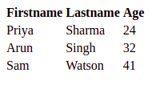

*Simple HTML Table*

**In this example:**

* <table>: This tag starts the table. Everything between the opening <table> and closing </table> tags makes up the table.
* <tr>: Stands for “table row”. Each <tr> tag defines a row in the table.
* <th>: Stands for “table header”. It’s used for the headers of the columns. In this case, “**Firstname**“, “**Lastname**“, and “**Age**” are headers. Text in <th> tags is usually bold and centered by default.
* <td>: Stands for “table data”. This tag is used for actual data cells under each column. For instance, “**Priya**” is the data under the “**Firstname**” header, “**Sharma**” under the “**Lastname**“, and “**24**” under the “**Age**“.
* The first <tr> has three <th> elements, setting up the column titles.
* The subsequent <tr> tags each contain three <td> elements, representing the data for each person listed in the table.

When this HTML code is rendered in a web browser, it will display a table with four rows (one header row plus three data rows) and three columns (Firstname, Lastname, Age), showing the names and ages of Priya, Arun, and Sam.

**Tags used in HTML Tables**

| **HTML Tags** | **Descriptions** |
| --- | --- |
| [<table>](https://www.geeksforgeeks.org/html-tables) | Defines the structure for organizing data in rows and columns within a web page. |
| [<tr>](https://www.geeksforgeeks.org/html-tr-tag) | Represents a **row** within an HTML table, containing individual cells. |
| [<th>](https://www.geeksforgeeks.org/differentiate-between-th-thead-tags-in-html-table) | Shows a table **header** cell that typically holds titles or headings. |
| [<td>](https://www.geeksforgeeks.org/html-td-tag) | Represents a standard **data** cell, holding content or data. |
| [<caption>](https://www.geeksforgeeks.org/html-caption-tag) | Provides a title or description for the entire table. |
| [<thead>](https://www.geeksforgeeks.org/html-thead-tag) | Defines the header section of a table, often containing column labels. |
| [<tbody>](https://www.geeksforgeeks.org/html-tbody-tag) | Represents the main content area of a table, separating it from the header or footer. |
| [<tfoot>](https://www.geeksforgeeks.org/html-tfoot-tag) | Specifies the footer section of a table, typically holding summaries or totals. |
| [<col>](https://www.geeksforgeeks.org/html-col-tag) | Defines attributes for table **columns** that can be applied to multiple columns at once. |
| [<colgroup>](https://www.geeksforgeeks.org/html-colgroup-tag) | Groups together a **set of columns** in a table to which you can apply formatting or properties collectively. |

**Another Example of HTML Table:**

Creating a simple table in HTML using a table tag.



1

<!-- index.html -->

2

<!DOCTYPE html>

3

<html>

4

​

5

<body>

6

<table>

7

<tr>

8

<th>Book Name</th>

9

<th>Author Name</th>

10

<th>Genre</th>

11

</tr>

12

<tr>

13

<td>The Book Thief</td>

14

<td>Markus Zusak</td>

15

<td>Historical Fiction</td>

16

</tr>

17

<tr>

18

<td>The Cruel Prince</td>

19

<td>Holly Black</td>

20

<td>Fantasy</td>

21

</tr>

22

<tr>

23

<td>The Silent Patient</td>

24

<td> Alex Michaelides</td>

25

<td>Psychological Fiction</td>

26

</tr>

27

</table>

28

</body>

29

​

30

</html>

**Output:**

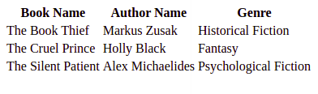

*HTML Table*

**Styling HTML Tables**

Styling an HTML table can significantly improve its appearance and readability. You can use [CSS (Cascading Style Sheets)](https://www.geeksforgeeks.org/css-tutorial/) to add styles such as borders, background colors, text alignments, and much more. Here are some basic styles to make your table look neater and more professional:

**1. Adding a Border to an HTML Table**

A border is set using the CSS border property. If you do not specify a border for the table, it will be displayed without borders.

**Syntax**

table, th, td {  
 border: 1px solid black;  
}

**Example**: Addition of the border to the HTML Table.



1

<!-- index.html -->

2

<!DOCTYPE html>

3

<html>

4

​

5

<head>

6

<style>

7

table,

8

th,

9

td {

10

border: 1px solid black;

11

}

12

</style>

13

</head>

14

​

15

<body>

16

<table style="width:100%">

17

<tr>

18

<th>Firstname</th>

19

<th>Lastname</th>

20

<th>Age</th>

21

</tr>

22

<tr>

23

<td>Priya</td>

24

<td>Sharma</td>

25

<td>24</td>

26

</tr>

27

<tr>

28

<td>Arun</td>

29

<td>Singh</td>

30

<td>32</td>

31

</tr>

32

<tr>

33

<td>Sam</td>

34

<td>Watson</td>

35

<td>41</td>

36

</tr>

37

</table>

38

</body>

39

​

40

</html>

**Output:**

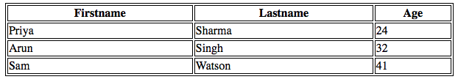

*HTML Table with border*

**2. Adding Collapsed Borders in an HTML Table**

For borders to collapse into one border, add the CSS border-collapse property.

**Syntax**

table, th, td {  
 border: 1px solid black;  
 border-collapse: collapse;  
 }

**Example:**Addition of Collapsed Borders in HTML.



1

<!-- index.html -->

2

<!DOCTYPE html>

3

<html>

4

​

5

<head>

6

<style>

7

table,

8

th,

9

td {

10

border: 1px solid black;

11

border-collapse: collapse;

12

}

13

</style>

14

</head>

15

​

16

<body>

17

<table style="width:100%">

18

<tr>

19

<th>Firstname</th>

20

<th>Lastname</th>

21

<th>Age</th>

22

</tr>

23

<tr>

24

<td>Priya</td>

25

<td>Sharma</td>

26

<td>24</td>

27

</tr>

28

<tr>

29

<td>Arun</td>

30

<td>Singh</td>

31

<td>32</td>

32

</tr>

33

<tr>

34

<td>Sam</td>

35

<td>Watson</td>

36

<td>41</td>

37

</tr>

38

</table>

39

</body>

40

​

41

</html>

**Output:**

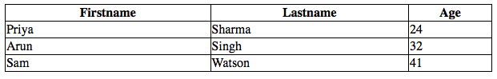

*HTML Table with Collapsed Borders*

**3. Adding Cell Padding in an HTML Table**

Cell padding specifies the space between the cell content and its borders. If we do not specify a padding, the table cells will be displayed without padding.

**Syntax**

th, td {  
 padding: 20px;  
}

**Example:**Addition of Table cell padding in HTML.



1

<!-- index.html -->

2

<!DOCTYPE html>

3

<html>

4

​

5

<head>

6

<style>

7

table,

8

th,

9

td {

10

border: 1px solid black;

11

border-collapse: collapse;

12

}

13

14

th,

15

td {

16

padding: 20px;

17

}

18

</style>

19

</head>

20

​

21

<body>

22

<table style="width:100%">

23

<tr>

24

<th>Firstname</th>

25

<th>Lastname</th>

26

<th>Age</th>

27

</tr>

28

<tr>

29

<td>Priya</td>

30

<td>Sharma</td>

31

<td>24</td>

32

</tr>

33

<tr>

34

<td>Arun</td>

35

<td>Singh</td>

36

<td>32</td>

37

</tr>

38

<tr>

39

<td>Sam</td>

40

<td>Watson</td>

41

<td>41</td>

42

</tr>

43

</table>

44

</body>

45

​

46

</html>

**Output:**

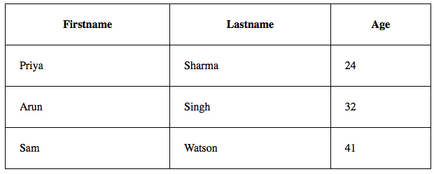

*Adding Table cell padding*

**4. Adding Left Align Headings in an HTML Table**

By default, the table headings are bold and centered. To left-align the table headings, we must use the CSS text-align property.

**Syntax**

th {  
 text-align: left;  
}

**Example:**Explains the [text-align property](https://www.geeksforgeeks.org/css-text-align-property) where the text is aligned to the left.



1

<!-- index.html -->

2

<!DOCTYPE html>

3

<html>

4

​

5

<head>

6

<style>

7

table,

8

th,

9

td {

10

border: 1px solid black;

11

border-collapse: collapse;

12

}

13

​

14

th,

15

td {

16

padding: 20px;

17

}

18

​

19

th {

20

text-align: left;

21

}

22

</style>

23

</head>

24

​

25

<body>

26

<table style="width:100%">

27

<tr>

28

<th>Firstname</th>

29

<th>Lastname</th>

30

<th>Age</th>

31

</tr>

32

<tr>

33

<td>Priya</td>

34

<td>Sharma</td>

35

<td>24</td>

36

</tr>

37

<tr>

38

<td>Arun</td>

39

<td>Singh</td>

40

<td>32</td>

41

</tr>

42

<tr>

43

<td>Sam</td>

44

<td>Watson</td>

45

<td>41</td>

46

</tr>

47

</table>

48

</body>

49

​

50

</html>

**Output:**

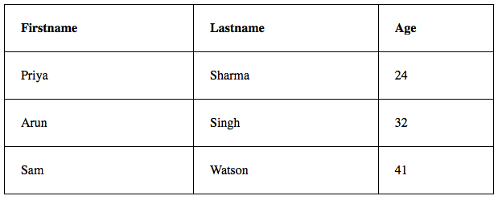

*text-align Property*

**5. Adding Border Spacing in an HTML Table**

Border spacing specifies the space between the cells. To set the border-spacing for a table, we must use the CSS border-spacing property.

**Syntax**

table {  
 border-spacing: 5px;  
}

**Example:**Explains the [border space](https://www.geeksforgeeks.org/css-border-spacing-property) property to make the space between the Table cells.



1

<!-- index.html -->

2

<!DOCTYPE html>

3

<html>

4

​

5

<head>

6

<style>

7

table,

8

th,

9

td {

10

border: 1px solid black;

11

}

12

​

13

table {

14

border-spacing: 5px;

15

}

16

</style>

17

</head>

18

​

19

<body>

20

<table style="width:100%">

21

<tr>

22

<th>Firstname</th>

23

<th>Lastname</th>

24

<th>Age</th>

25

</tr>

26

<tr>

27

<td>Priya</td>

28

<td>Sharma</td>

29

<td>24</td>

30

</tr>

31

<tr>

32

<td>Arun</td>

33

<td>Singh</td>

34

<td>32</td>

35

</tr>

36

<tr>

37

<td>Sam</td>

38

<td>Watson</td>

39

<td>41</td>

40

</tr>

41

</table>

42

</body>

43

​

44

</html>

**Output:**

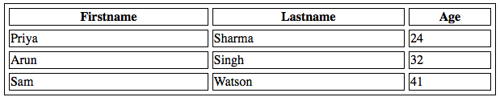

*Border Spacing Property*

**6. Adding Cells that Span Many Columns in HTML Tables**

To make a cell span more than one column, we must use the colspan attribute.

**Example:** Use of [colspan attribute](https://www.geeksforgeeks.org/html-colspan-attribute) in HTML.



1

<!-- index.html -->

2

<!DOCTYPE html>

3

<html>

4

​

5

<head>

6

<style>

7

table,

8

th,

9

td {

10

border: 1px solid black;

11

border-collapse: collapse;

12

}

13

​

14

th,

15

td {

16

padding: 5px;

17

text-align: left;

18

}

19

</style>

20

</head>

21

​

22

<body>

23

<h2>Cell that spans two columns:</h2>

24

<table style="width:100%">

25

<tr>

26

<th>Name</th>

27

<th colspan="2">Telephone</th>

28

</tr>

29

<tr>

30

<td>Vikas Rawat</td>

31

<td>9125577854</td>

32

<td>8565557785</td>

33

</tr>

34

</table>

35

</body>

36

​

37

</html>

**Output:**

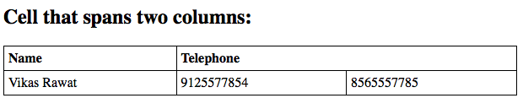

*colspan attribute*

**7. Adding Cells that span many rows in HTML Tables**

To make a cell span more than one row, we must use the rowspan attribute.

**Example:**Use of the [rowspan attribute](https://www.geeksforgeeks.org/html-rowspan-attribute) in HTML.



1

<!-- index.html -->

2

<!DOCTYPE html>

3

<html>

4

​

5

<head>

6

<style>

7

table,

8

th,

9

td {

10

border: 1px solid black;

11

border-collapse: collapse;

12

}

13

​

14

th,

15

td {

16

padding: 5px;

17

text-align: left;

18

}

19

</style>

20

</head>

21

​

22

<body>

23

<h2>Cell that spans two rows:</h2>

24

<table style="width:100%">

25

<tr>

26

<th>Name:</th>

27

<td>Vikas Rawat</td>

28

</tr>

29

<tr>

30

<th rowspan="2">Telephone:</th>

31

<td>9125577854</td>

32

</tr>

33

<tr>

34

<td>8565557785</td>

35

</tr>

36

</table>

37

</body>

38

​

39

</html>

**Output:**

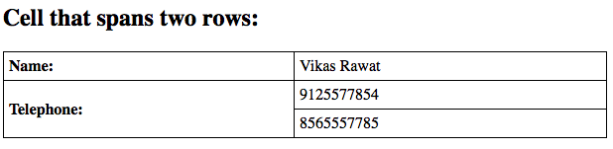

*Use of rowspan attribute*

**8. Adding a**[**Caption**](https://www.geeksforgeeks.org/html-caption-tag)**in an HTML Table**

To add a caption to a table, we must use the “caption” tag.

**Syntax**

<table style="width:100%">  
<caption>DETAILS</caption>

**Example:** HTML Table caption by specifying the CSS properties for setting its width.



1

<!-- index.html -->

2

<!DOCTYPE html>

3

<html>

4

​

5

<head>

6

<style>

7

table,

8

th,

9

td {

10

border: 1px solid black;

11

border-collapse: collapse;

12

}

13

​

14

th,

15

td {

16

padding: 20px;

17

}

18

​

19

th {

20

text-align: left;

21

}

22

</style>

23

</head>

24

​

25

<body>

26

<table style="width:100%">

27

<caption>DETAILS</caption>

28

<tr>

29

<th>Firstname</th>

30

<th>Lastname</th>

31

<th>Age</th>

32

</tr>

33

<tr>

34

<td>Priya</td>

35

<td>Sharma</td>

36

<td>24</td>

37

</tr>

38

<tr>

39

<td>Arun</td>

40

<td>Singh</td>

41

<td>32</td>

42

</tr>

43

<tr>

44

<td>Sam</td>

45

<td>Watson</td>

46

<td>41</td>

47

</tr>

48

</table>

49

</body>

50

​

51

</html>

**Output:**

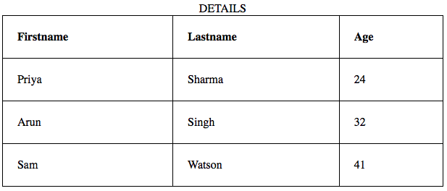

*Adding the caption using the tag*

**9. Adding a Background Colour to the Table**

A color can be added as a background in an HTML table using the “*background-color*” option.

**Syntax**

table#t01 {  
 width: 100%;  
 background-color: #f2f2d1;  
 }

**Example:** Addition of the Table background color in HTML.



1

<!-- index.html -->

2

<!DOCTYPE html>

3

<html>

4

​

5

<head>

6

<style>

7

table,

8

th,

9

td {

10

border: 1px solid black;

11

border-collapse: collapse;

12

}

13

​

14

th,

15

td {

16

padding: 5px;

17

text-align: left;

18

}

19

​

20

table#t01 {

21

width: 100%;

22

background-color: #f2f2d1;

23

}

24

</style>

25

</head>

26

​

27

<body>

28

<table style="width:100%">

29

<tr>

30

<th>Firstname</th>

31

<th>Lastname</th>

32

<th>Age</th>

33

</tr>

34

<tr>

35

<td>Priya</td>

36

<td>Sharma</td>

37

<td>24</td>

38

</tr>

39

<tr>

40

<td>Arun</td>

41

<td>Singh</td>

42

<td>32</td>

43

</tr>

44

<tr>

45

<td>Sam</td>

46

<td>Watson</td>

47

<td>41</td>

48

</tr>

49

</table>

50

<br />

51

<br />

52

<table id="t01">

53

<tr>

54

<th>Firstname</th>

55

<th>Lastname</th>

56

<th>Age</th>

57

</tr>

58

<tr>

59

<td>Priya</td>

60

<td>Sharma</td>

61

<td>24</td>

62

</tr>

63

<tr>

64

<td>Arun</td>

65

<td>Singh</td>

66

<td>32</td>

67

</tr>

68

<tr>

69

<td>Sam</td>

70

<td>Watson</td>

71

<td>41</td>

72

</tr>

73

</table>

74

</body>

75

​

76

</html>

**Output:**

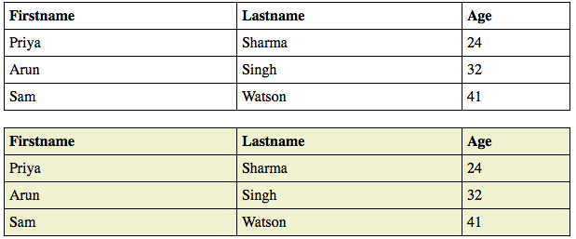

*Adding Table Background color using CSS properties*

**10. Creating Nested Tables**

Nesting tables simply means making a Table inside another Table. Nesting tables can lead to complex tables layouts, which are visually interesting and have the potential of introducing errors.

**Example:**Nesting of HTML Table.



1

<!-- index.html -->

2

<!DOCTYPE html>

3

<html>

4

​

5

<body>

6

<table border=5 bordercolor=black>

7

<tr>

8

<td> First Column of Outer Table </td>

9

<td>

10

<table border=5 bordercolor=grey>

11

<tr>

12

<td> First row of Inner Table </td>

13

</tr>

14

<tr>

15

<td> Second row of Inner Table </td>

16

</tr>

17

</table>

18

</td>

19

</tr>

20

</table>

21

</body>

22

​

23

</html>

**Output:**

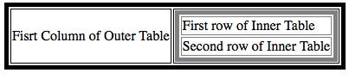

*Nested HTML Table*

**Supported Browsers**

* Google Chrome 15
* Edge 12
* Firefox 1
* Opera 14
* Safari 6

—> HTML is the foundation of webpages, is used for webpage development by structuring websites and web apps. You can learn HTML from the ground up by following this [HTML Tutorial](https://www.geeksforgeeks.org/html-tutorials) and [HTML Examples.](https://www.geeksforgeeks.org/html-examples)

**HTML Tables – FAQs**

**How do I create a table in HTML?**

*Use the <table> tag with nested <tr> (table row) and <td> (table data) tags to create rows and cells.*

**What are HTML tables**